TENDER NOTICE
Tender Title: Procurement of Starter kits for Young Farmer Groups supported by the SHORA NEZA Project (8 Lots)
Tender Publication Date | July 3, 2026
Submission Deadline | July 9, 2026, at 03:00PM
Opening Date Time | July 9, 2026, at 03:30PM
Submission Location | DUHAMIC-ADRI Head Office, Kicukiro-Niboye (only hard copy submissions are accepted)
Inquiry Contact Email | procurement@duhamic.org.rw
Sample visit location  & dates | DUHAMIC-ADRI head office, July 8,2026 (From 08:00AM to 05:00PM)

1. Brief description of DUHAMIC-ADRI

DUHAMIC -ADRI is a non-profit organization located in Kigali, the capital city of Rwanda, in Kicukiro District, Niboye Sector. Officially operating in Rwanda since 12th July 1985.

Mission: Supporting integrated initiatives for Holistic Development of Rural Population in their struggle for self-reliance’
Vision: A rural world responsible for its self-socio-economic development
Core Values: Integrity, Professionalism, Transparency

Introduction of SHORANEZA Project
The SHORA NEZA is a Project implemented by DUHAMIC-ADRI in partnership with World Food Program (WFP) with fundings from Mastercard foundation, in Southern and Western Provinces of Rwanda aiming to create new and strengthen existing employment opportunities for young males and females with the age range of 18 to 35 years old through strengthening food systems, while considering their different needs, through strengthened, interlinked, and efficient agricultural value chains.

- Purpose of the tender
The purpose of this tender is to procure starter kits for 139 Young Farmer Groups (YFGs) operating across 15 districts in the Southern and Western Provinces of Rwanda, under the SHORA NEZA Project Accordingly, DUHAMIC-ADRI has planned to provide the required starter kits to the Farmer Service Centers.
- Scope of work
This tender is divided into eight (8) lots. The detailed quantities of the starter kits to be procured are provided in the tables below, which also serve as the financial proposal (quotation) templates.
LOT 1. Procurement of bee keeping equipment and tools
No | Items | Technical specifications | Qty | Unit Price (Rwf) | Total Price (Rwf)
1 | Bee smoker | Stainless steel,corium (736g) • Material: Stainless Steel, Corium  • Overall height: 28.5cm  • Barrel height: 19.3cm  • Barrel diameter: 10cm  • Weight: 736g | 1
2 | Beehives | Langstroth (local made in greveria with 2 boxes (super and bottom) • Made in Grevillea timber well dried, Cover with metal sheet  • Have two box (super and bottom)  • Each box must have 10 frames  • Box Size length 51cm, width41, height 23.5cm  • Color yellow or blue  • The measure of item is Kits | 15
3 | Honey cups | Honey packaging Boxes in plastic and with 1 kg of size | 700
4 | Four Frame Manual Honey Extractor | • Material in stainless steel •4 Frames Manual Honey Extractor  • Manual, 201SS Barrel + 304SS inner basket  • Barrel diameter:47cm  • Barrel height:60cm  • Inner basket size: 42*26cm | 2
5 | PPEs for honey harvest (complete) | Made by 1. Bee Suit (Material: cotton,Fireproofing net,With veil and zipper,Weight:730g/pc,Size: XL,Color: White and Khaki  2. Beekeeping protective gloves (Material: sheepskin, Size: X Color: yellow)  3. Beekeeping hat (Material: cotton,Color: white,With veil and combo,Weight: 80g/pc) 4. Beekeeping boots/protective footwear (Color: white, Size:8) | 1
6 | Honey press (wax press) | Staineless steel/ Material in stainless steel, Diameter: 30/23cm, 1pc/carton 38*35*57cm 8.3kgs
Grand Total

Distribution of bee keeping kits to Districts

# | ITEMS | HUYE | NGORORERO | NYABIHU | RUHANGO
1 | Bee smoker |  |  | 1
2 | Beehives | 5 | 6 |  | 4
3 | Honey cups |  |  | 700
4 | Four Frame Manual Honey Extractor | 1 |  |  | 1
5 | PPEs for honey harvest (complete) |  |  |  | 1
6 | Honey press (wax press) |  | 1

LOT 2: Hardeware (Quincaillerie) items
No | Items | Technical specifications | Qty | Unit Price (Rwf) | Total Price (Rwf)
1 | Fencing wire/Senyenge(chain-line fence) | Galvanized Chain Link Fence with thickness of 1.6 rolls with 13 meters made in Rwanda | 10
2 | Hoes (known as Cyapa nkoko) | (known as Cyapa nkoko) | 514
3 | Three pronged hoes (known as Cyapa nkoko) | (known as Cyapa nkoko) | 106
4 | Iron sheets (BG 32) | (BG 32) | 30
5 | Rakers/Lateau | In metallic | 14
6 | Shade Net (L 180/50 m) | Shade Net (L 180/50 m) | 5
7 | Sheeting (Blue &White color with 4/5) | Blue &White color with 4/5 | 84
8 | Wheelbarrow | Material: Steel, with Ipine ry'amano | 84
Grand Total

Distribution of Hardware kits to Districts

# |  | STARTER KITS SUPPLY PER EACH DISTRICT
Item |  | GISAGARA | HUYE | KAMONYI | KARONGI | MUHANGA | NGORORERO | NYABIHU | NYAMAGABE | NYAMASHEKE | NYANZA | NYARUGURU | RUBAVU | RUHANGO | RUTSIRO
1 | Fencing wire/Senyenge(chain-line fence) |  |  |  |  |  |  | 10
2 | Hoes (known as Cyapa nkoko) | 40 | 139 |  | 20 | 35 | 25 | 20 | 30 | 43 |  | 122 |  | 30 | 10
3 | Three pronged hoes (known as Cyapa nkoko) |  |  |  | 29 | 12 |  |  |  | 65
4 | Iron sheets (BG 32) |  |  |  |  |  |  |  |  |  |  |  | 30 | 0
5 | Rakers/Lateau |  |  | 14
6 | Shade Net (L 180/50 m) |  |  |  |  | 2 |  | 1 |  | 2
7 | Sheeting (Blue &White color with 4/5) |  |  |  |  | 18 |  |  | 29 |  | 19 |  |  | 6 | 12
8 | Wheelbarrow |  | 13 |  | 4 | 1 | 3 |  | 14 | 7 | 4 | 15 | 9 | 14

LOT 3: Procurement of Agriculture tools & machineries
No | Items | Technical specifications | Qty | Unit Price (Rwf) | Total Price (Rwf)
1 | Agriculture Safety Boots | Black boots/Sandaka or Kenafrican | 75
2 | Charged Spraying Pumps (18 Ltrs) OMNI Agricultural LTD Israel | OMNI from Isreal Capacity 18 L (size 38X20X50 cm) | 6
3 | Pressure sprayer 20lt (back pack) | With capacity of 20liters, back pack. | 6
4 | Spraying Pumps Knapsack Sprayer (GP15) | Knapsack Sprayer (GP15) | 155
5 | Chicken drinker (10L) | Material in durable plastics, capacity of (10 L) and color White/Red | 62
6 | Chicken Feeders (10kg) | Material in durable plastics, capacity of (10 Kgs) and color White/Red | 20
7 | Chicken feeders (6kg) | Material in durable plastics, capacity of (6 Kgs) and color White/Red | 33
8 | Crates for Vegetables & fruits | Medium Size in Plastic | 61
9 | Germination crate/seed starter tray | Nursery seedling trays with 66 holes in black color | 43
10 | Grinder machine, Hasia (Dynamo 7.5 kw, Direct | (Dynamo 7.5 kw) | 2
11 | Corn Thresher Machine | Model: 5T60S, rated rotary speed 1500 rpm, matched power2.5-5HP, capacity >/= 1,000 kg/h , Standard: JB/T10749 | 1
12 | Glass Chopper Machine | Electical motor:3KW, Capacity 700Kgs/Hour, material merd steel | 1
13 | Shaff cutter | (Model:GAM600) rated rotary speed 1100 rpm, matched power3-5HP, capacity >/= 1,000 kg/h , Standard: JB/T9707 | 1
14 | Milk Can (50 L) | Stainless Steel with 50L  Material: AISI 304 Food Grade Stainless Steel  Surface Finish: Inside and outside polished (mirror finish)  Closure: Three-lock system with silicone seal | 2
15 | Small Milk can (20L) | Stainless Steel with 30L  Material: AISI 304 Food Grade Stainless Steel  Surface Finish: Inside and outside polished (mirror finish)  Closure: Three-lock system with silicone seal | 3
16 | Watering cans | Polyethylene plastic with capacity of 9 liters | 187
17 | Seedlings bags (12cm) | Ibihoho material in plastic and with size of 12 Cm | 117
Grand Total (All taxes inclusive)

Distribution of Agriculture tools & machineries to Districts
No | Items | GISAGARA | HUYE | KAMONYI | KARONGI | MUHANGA | NGORORERO | NYABIHU | NYAMAGABE | NYAMASHEKE | NYANZA | NYARUGURU | RUBAVU | RUHANGO | RUTSIRO
1 | Agriculture Safety Boots |  |  |  |  | 20 |  |  |  |  |  |  |  |  | 55
2 | Charged Spraying Pumps (18 Ltrs) OMNI Agricultural LTD Israel |  |  |  |  |  |  |  |  |  | 6
3 | Pressure sprayer 20lt (back pack) | 5 |  | 1
4 | Spraying Pumps Knapsack Sprayer (GP15) |  | 15 | 8 | 4 | 8 | 4 | 4 | 39 | 10 | 23 | 19 | 7 | 10 | 4
5 | Chicken drinker (10L) |  |  |  |  |  |  |  |  |  |  |  | 35 | 27
6 | Chicken Feeders (10kg) |  |  |  |  |  |  |  |  |  |  | 20
7 | Chicken feeders (6kg) |  |  |  |  |  |  |  |  |  |  |  | 5 | 28
8 | Crates for Vegetables & fruits | 7 | 19 | 8 |  | 19 |  |  |  |  |  |  |  | 8
9 | Germination crate/seed starter tray |  |  |  |  | 43
10 | Grinder machine, Hasia (Dynamo 7.5 kw, Direct |  | 2
11 | Corn Thresher Machine |  |  |  |  |  |  |  |  | 1
12 | Glass Chopper Machine |  |  |  |  | 1
13 | Shaff cutter |  | 1
14 | Milk Can (50 L) | 2
15 | Small Milk can (20L) | 3
16 | Watering cans |  | 70 |  |  |  |  |  | 66 | 38 |  | 13
17 | Seedlings bags (12cm) |  |  |  |  | 75 |  |  |  |  |  |  |  | 42

LOT 4: Procurement of Irrigation Generators and accessories
No | Items | Technical specifications | Qty | Unit Price (Rwf) | Total Price (Rwf)
1 | Irrigation pump with its accessories | Irrigation Pump Generator (Petrol engine water pump 2 inch (KOSHIN), Q:37.2m3/h @TDH:27m. Suction lift 7-8m with Flexible suction pipe 2inch and with layflate hose pipe 2 inches, 100m long). | 84
2 | Irrigation Horse pipe in PVC flexible with size 1” X50 in meter | In PVC flexible with size 1” X50 in meter (in m) | 275
Grand Total (All taxes inclusive)

Distribution of irrigation generators to districts
# | Items | GISAGARA | HUYE | KAMONYI | KARONGI | MUHANGA | NGORORERO | NYAMAGABE | NYAMASHEKE | NYANZA | NYARUGURU | RUHANGO | RUSIZI | RUTSIRO
1 | Irrigation pump with its accessories | 9 | 11 | 3 | 2 | 8 | 1 | 7 | 14 | 8 | 7 | 8 | 2 | 4
2 | Irrigation Horse pipe in PVC flexible with size 1” X50 in meter |  | 100 |  |  |  |  |  |  | 175

LOT 5: Procurement of IT Equipment
No | Items | Technical specifications | Quantity | Unit Price (Rwf) | Total Price (Rwf)
1 | Laptop | Brand New, (V14/15 Laptop, inter celeron 1.1 GHz RAM:8GB Storage: 256GB SSD GPU: INTEGRATED Display:14.0" HD Win 11 Pro) | 6
Grand Total (All taxes inclusive)

Distribution of IT Equipment
# | Item | MUHANGA | NGORORERO | NYABIHU | NYAMAGABE | NYAMASHEKE | NYANZA | NYARUGURU | RUBAVU | RUHANGO | RUSIZI
1 | Laptop | 2 |  |  | 1 | 2 |  |  |  |  | 1
Lot 6: Procurement of Electronic equipment
No | Items | Technical specifications | Quantity | Unit Price (Rwf) | Total Price (Rwf)
1 | Electronic Scale Big 300kg | TCS-300 Kg: price scale  Capacity: max 300kg; min: 2kg  Accuracy: 100g or 0.1 kg  Power supply: AC 220V and dc (Built-in rechargeable battery:  Rating power: 10AV (Typically less than 8VA during operation)  Display: LED or LCD (typically red LED display), 5-digit weight window, 5-digit unit price window, 6-digit total price window  Platform Material: Stainless iron/steel platform (often checker plate to reduce slipping)  Operating Temperature: 0°C to 40°C  Interface (Optional): RS232/RS485/Printer/Bluetooth | 16
2 | Fridge SAYONA SRF 276 L | Fridge with capacity of 276 L, Voltage:220V-240V/50HZ, Main Material: Stainless steel and aluminum coated, unity dimension: 550X550X1430mm, Net Weight: 38kgs, GlossmWeight:42kgs | 2

Distribution of Electronic equipment to Districts
# | Item | GISAGARA | HUYE | KARONGI | NYABIHU | NYAMAGABE | NYAMASHEKE | NYARUGURU | RUBAVU | RUHANGO
1 | Electronic Scale Big 300kg | 1 | 4 | 1 | 1 | 3 | 2 | 1 | 2 | 1
2 | Fridge SAYONA SRF 276 L |  |  |  |  |  |  |  |  | 2
Lot 7: Procurement of Transport Equipment
No | Items | Technical specifications | Qty | Unit Price (Rwf) | Total Price  (Rwf)
1 | Bicycle | Frame & Fork: (Steel Lug Type,Single Bar Frame & Fork, Brazed,Enamelled), Handle Bar:PH-Type,Raised Bar,BNCP, Handle Bar: 46Tx170mm Steel,Cottered Cranks,BNCP Freewheel: 1/2”x1/8”x18T Pedal:Fine Diamond Rubbers,Eastman,Engraved Brakes: Side Pull,Rim Brakes,BNCP/ZP Saddle: PVC Cover,Plastic Base,Rear Single,Coil Springs Rims: Steel Westwood,Pattern,28”x1.1-2”x32/40H,BNCP Tyre & Tubes: Black Tyres & Tubes,28”x1.1/2”with D/V Accessoiries: Bell,Channel Carrier,Full Stand & Ring Lock | 231
Grand total (All taxes inclusive)

Distribution of Transport Equipment to Districts
# | Item | GISAGARA | HUYE | KAMONYI | KARONGI | MUHANGA | NGORORERO | NYABIHU | NYAMAGABE | NYAMASHEKE | NYANZA | NYARUGURU | RUBAVU | RUHANGO | RUSIZI | RUTSIRO
1 | Bicycle | 30 | 45 | 2 | 17 | 9 | 6 | 7 | 9 | 39 | 12 | 24 | 7 | 13 | 2 | 9
Lot 8: Procurement of Storage equipment
No | Items | Technical specifications | Qty | Unit Price (Rwf) | Total Price (Rwf)
1 | Water tank 5000 L | Material: Good quality of Polyethylene/Plastic  -Type: Rain water harvesting Tank  -Capacity:5000 Liters  -Model: Harvesting rainwater  -Size Diameter: Not less than 180cm  -Height: Not less than 220Cm  - Thickness: 7-10 mm | 7
2 | Water tank (3000L) | Material: Good quality of Polyethylene/Plastic  -Type: Rain water harvesting Tank  -Capacity:3000 Liters  -Model: Harvesting rainwater  _Diameter: Typically, 1.60m to 1.65m (160cm to 165cm)  _Height: Typically, 1.60m to 1.74m (160cm to 174cm)  _Thickness: Typically, 6mm to 8mm | 9
3 | Water tank (1000L) | Material: Good quality of Polyethylene/Plastic  -Type: Rain water harvesting Tank  -Capacity:1000 Liters  -Model: Harvesting rainwater  _Diameter: Typically, 1.04m to 1.13m (104cm to 113cm)  -Height: Typically, 1.16m to 1.42m (116cm to 142m)  -Thickness: Typically, 4mm to 6mm. | 2
# | Item | HUYE1 | MUHANGA | NYABIHU | NYAMASHEKE | NYARUGURU | RUBAVU | RUHANGO | RUSIZI
1 | Water tank 5000 L |  |  | 2 | 3 | 1 |  |  | 1
2 | Water tank (3000L) |  | 1 |  |  | 2 | 5 | 1
3 | Water tank (1000L) | 2
Distribution of storage equipment to districts

Photo of different items
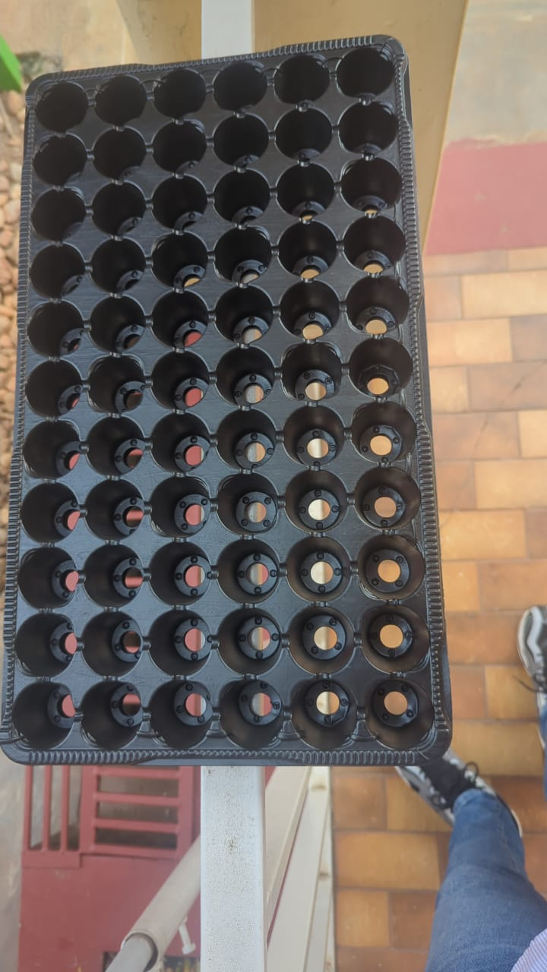
Germination crate
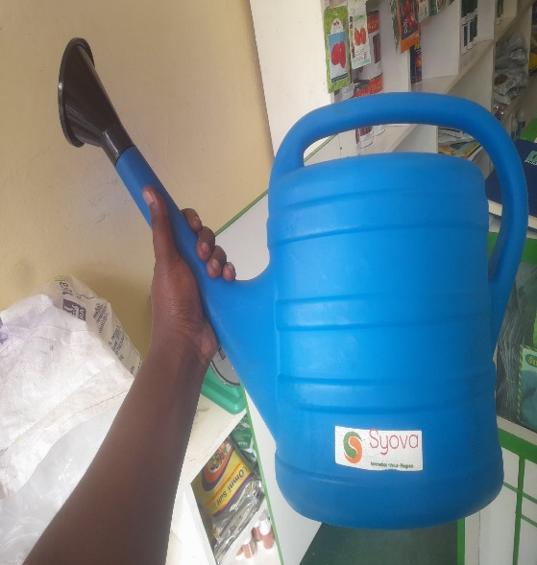
Watering can
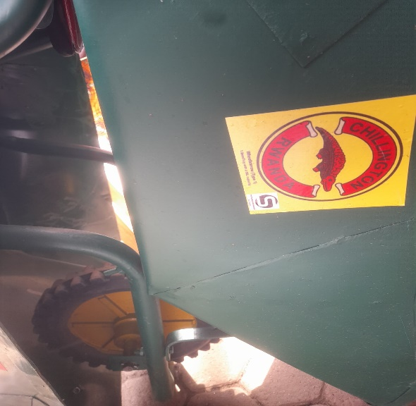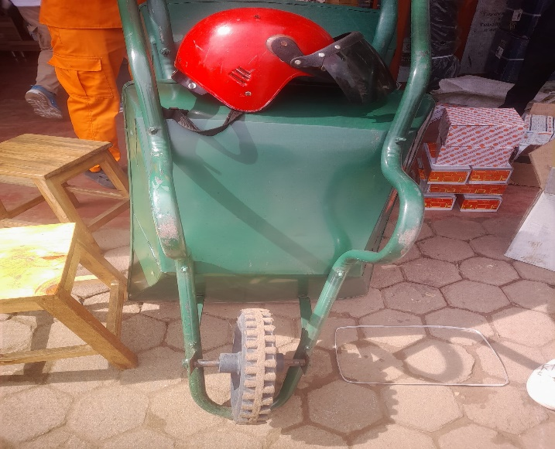

Wheelbarrow
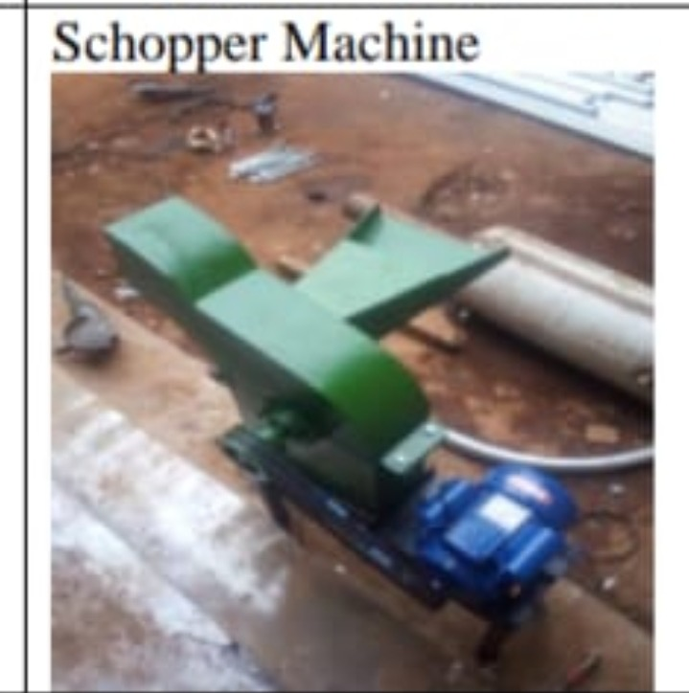
Glass Chopper Machine
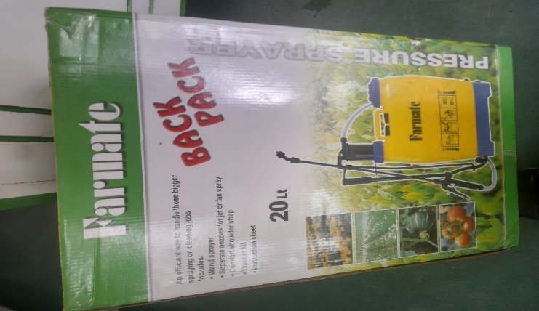
Spraying Pump
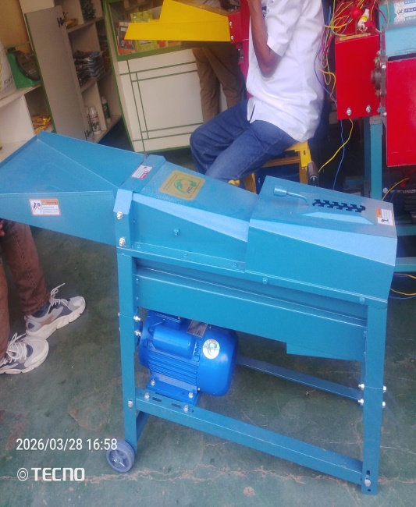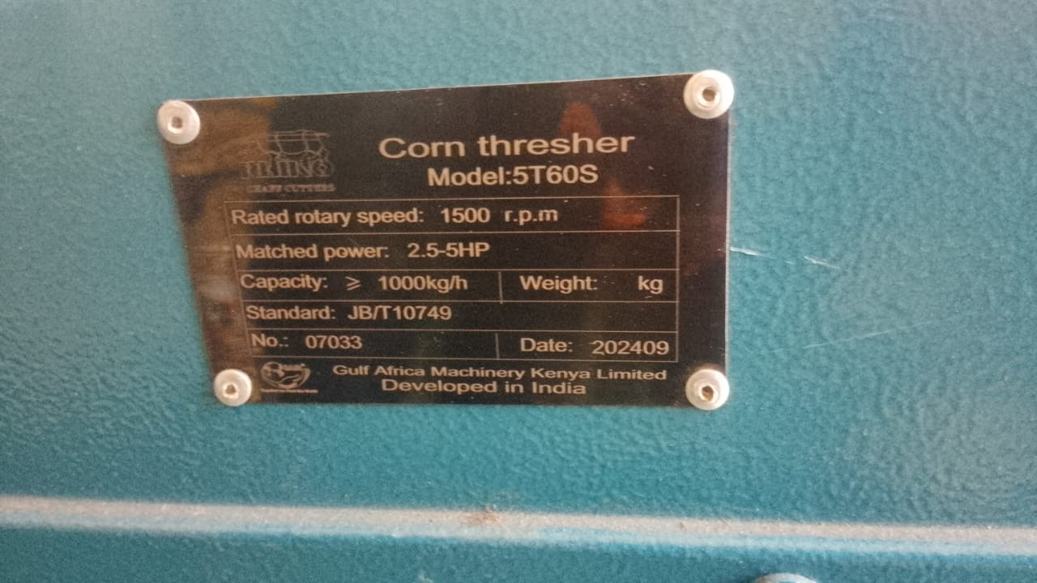
Corn thresher
5. Required Documents for Submission

- Application letter addressed to executive Secretary
- RDB certificate (certificate not related to the area of required items will be rejected)
- A valid RSSB clearance certificate.
- A valid tax clearance certificate issued by RRA.
- Proof of use of the Electronic Billing Machine (EBM) (An invoice submitted in the past or EBM usage certificate).
- 3 certificates of good completion with their purchase orders or contracts for similar work (certificate without purchase order or contract will be rejected)
- Commitment letter to deliver within 5 working days starting from the day of contract signing/receiving purchase order.
- Sample visit certificate issued by DUHAMIC-ADRI.
- Financial proposal including transport cost to mentioned districts and all applicable taxes
All the above documents are mandatory; failure to submit any of them will result in automatic disqualification.
Note:
- The interested bidders may apply for all lots but awarded maximum of two lots.
- The bidders shall provide at least one year for warranty period for Electronic equipment or agriculture machineries, fridge, irrigation, electronic scales and laptops)
- There is a scheduled mandatory sample visit (Wednesday July 8,2026) for some kits such as bicycles, fencing wire (Senyenge), Laptop, sheeting, chicken drinkers, chicken feeders.
- Successful bidders will be responsible for the transportation of those starter kits to districts where the young farmer groups operate.
- The financial proposal (quotation) shall be presented for each lot separately.
- Prior to contracting, DUHAMIC-ADRI may conduct a vetting process to the successful bidders to ensure compliance with anti-terrorism and other regulatory requirements.
- DUHAMIC-ADRI reserves the right to conduct due diligence on all references (Certificates of good completion) submitted by the bidder. If any reference is found to be unauthentic, the bidder shall be immediately disqualified. The same applies to all administrative documents, including but not limited to valid Tax Clearance and RSSB Clearance certificates.
- DUHAMIC-ADRI reserves the right to reject any item that does not meet the required specifications and available samples. Failure to replace rejected items shall result in rejection of the bid and consideration of the next-ranked bidder(s).
- Bidders who are blacklisted by RPPA are not eligible to participate in this tender. DUHAMIC-ADRI reserves the right to reject such bids.
- Women-, youth-, and persons-with-disabilities–led companies that meet the required conditions and qualifications are encouraged to apply.

6. Bid submission

The bid documents shall be submitted in a sealed envelope to the DUHAMIC-ADRI Head Office located at Kicukiro /Niboye no later than Thursday, July 9, 2026, at 03:00PM and the opening session at 03:30PM (only hard copies will be accepted). Clearly indicate your company name and lot number you are applying for on the envelope.
7. Safeguarding clause
Safeguarding and protection from Sexual Exploitation and Abuse (PSEA) is everyone’s responsibility who works directly or indirectly with DUHAMIC-ADRI services delivery and operations. All DUHAMIC-ADRI staff and affiliates, including volunteers and Suppliers; sub-Suppliers’ staff and implementing partners are required to adhere to DUHAMIC-ADRI’s full safeguarding and protection policy procedures and the separate Code of Conduct that always values principles of PSEA.
DUHAMIC-ADRI has a zero tolerance to Sexual Exploitation and any other form of abuse. Child and vulnerable abuse, exploitation, harassment, discrimination, and human trafficking are strongly prohibited behaviors. All implementing partners/suppliers who are contracting with DUHAMIC-ADRI must adhere to DUHAMIC-ADRI’s full safeguarding and protection policy in addition to the code of conduct.
By applying to this tender, the supplier, is committed to denounce and to report any safeguarding issues or fraud face to face or at the reporting email for safeguarding issues at” feedback@duhamic.org.rw”, Toll Free: 8470 and telephone number: 0788305329 without delays.
By applying to this tender as a supplier, I understand that DUHAMIC-ADRI has the right to ensure 100% compliance with safeguarding and protection policies via spot checks or any other form of control mechanisms. If my business isn’t compliant, DUHAMIC-ADRI will take appropriate measures or immediately stop the contract of financial support depending on the nature and severity of the safeguarding incident detected.
8. Data Protection and Confidentiality
The successful bidder shall comply with all applicable data protection and privacy laws in force in the Republic of Rwanda, including Law No. 058/2021 relating to the protection of personal data and privacy. Any personal data, confidential information, or organizational records accessed during contract execution shall be used solely for the purposes of performing the contract, kept strictly confidential, and protected against unauthorized access, disclosure, loss, or misuse. Such data shall not be shared with third parties without prior written authorization from DUHAMIC-ADRI, and any actual or suspected data breach shall be reported immediately.

Thank you for expressing interest in working with DUHAMIC-ADRI.
Done at Kigali June 3, 2026

MUHIGIRWA Benjamin
Executive Secretary

