WHO WE ARE

Welcome to ICB–Finance Experts Ltd
Your Trusted Financial Partner
Established in 2020, ICB–Finance Experts Ltd is a leading provider of comprehensive financial solutions designed to help businesses grow, manage risk, and achieve sustainable success.
Our firm is powered by a team of financial consultants, accountants, and tax specialists dedicated to delivering personalized and practical solutions. We offer a wide range of professional services, including:
- Financial Advisory and Business Strategy
- Bookkeeping and Accounting Services
- Tax Planning and Compliance
- QuickBooks and Financial Systems Training
At ICB–Finance Experts Ltd, we are driven by a commitment to professionalism, integrity, and excellence. Our mission is to empower individuals and organizations with actionable insights, sound financial management practices, and strategic guidance.
Our trainers are highly qualified, experienced, and committed to delivering high-quality practical training.
Partner with us — let’s build your financial success together.

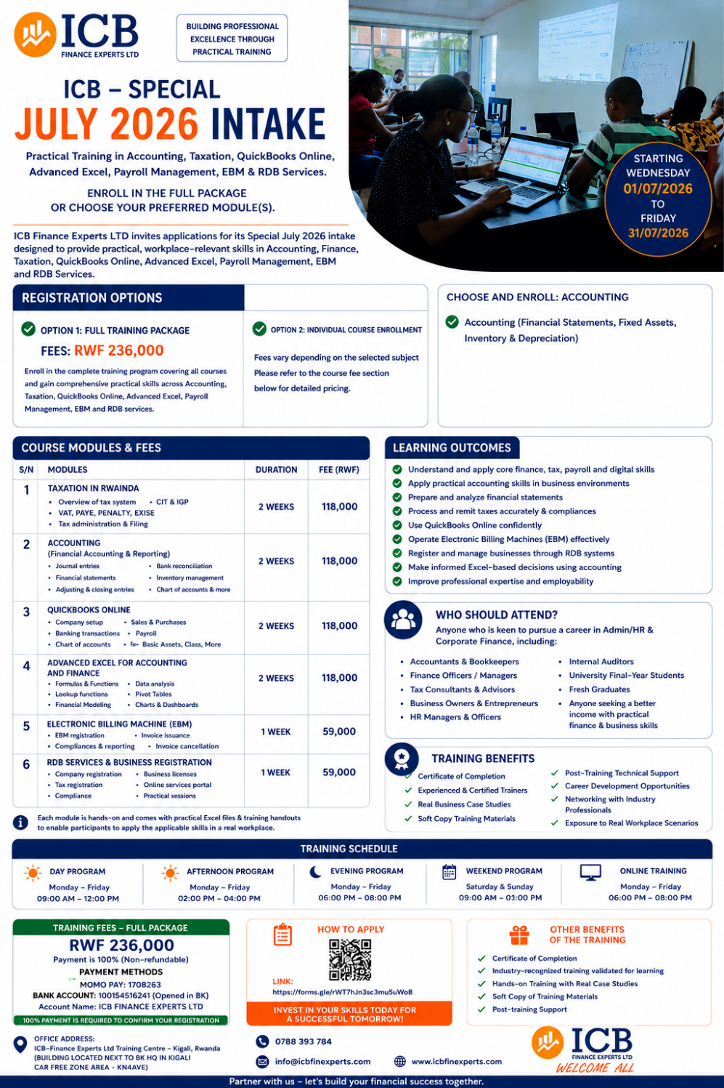
ICB–FINANCE EXPERTS LTD – SPECIAL JULY 2026 INTAKE - Practical Professional Training in Accounting, Taxation, QuickBooks Online, Advanced Excel, Payroll Management, EBM & RDB Services/Enroll in the Full Training Package or Choose Your Preferred Module(s).

ICB-FINANCE EXPERTS LTD invites applications for its Special July 2026 Intake designed to provide practical, workplace-oriented skills for Accountants, Finance Professionals, HR Officers, Business Owners, Final-Year Students, and Fresh Graduates.
Registration Options:
✅ Option 1: Full Training Package: FEES RWF 236,000
Enroll in the complete training program covering all courses and gain comprehensive practical skills across Accounting, Taxation, QuickBooks Online, Advanced Excel, Payroll Management, EBM, and RDB Services.
✅ Option 2: Choose and enroll in your preferred module(s): Fees vary depending on the selected subject. Please refer to the course fee structure below for detailed pricing.
Choose and enroll in the subject(s) of your choice:
- Accounting (Financial Statements Preparation)
- Taxation in Rwanda
- QuickBooks Online
- Advanced Excel for Accountants
- Payroll Management
- Electronic Billing Machine (EBM)
- RDB Services & Business Registration

Candidates who do not wish to undertake the Full Training Package may register for individual subject(s) and pay the applicable fee for each selected course as indicated in the fee structure.

SNO | Modules |  | Fee
1. TAXATION IN RWANDA | 1. TAXATION IN RWANDA  1.1 Introduction to the Rwandan Tax System  - Overview of Rwanda's tax structure and principles  - Roles and responsibilities of the Rwanda Revenue Authority (RRA)  - Understanding Corporate Income Tax (CIT) and Personal Income Tax (PIT)  - Taxpayer rights and obligations  - Tax registration procedures  1.2 Corporate Income Tax (CIT) & Quarterly Income Tax Prepayments (IQP)  Legal Framework and Taxable Entities  - Overview of tax legislation governing CIT  - Definition and scope of Corporate Income Tax  - Taxable entities and registration requirements  Taxable Income and Allowable Deductions  - Determination of taxable profits  - Allowable and non-allowable expenses  - Capital allowances and depreciation treatment  - Loss carry-forward provisions  CIT Rates and Tax Incentives  - Standard Corporate Income Tax rates  - Preferential tax rates and investment incentives  - Special tax regimes  Tax Compliance and Filing Requirements  - Annual Corporate Income Tax returns  - Quarterly Income Tax Prepayments (IQP)  - Filing deadlines and compliance requirements  - Penalties and interest for non-compliance  Practical Tax Exercises  - Computation of Corporate Income Tax  - Preparation and submission of tax declarations  - Real-life tax compliance case studies  1.3 Other Domestic, Payroll and Local Government Taxes  - Value Added Tax (VAT)  - Withholding Tax (WHT)  - Pay As You Earn (PAYE)  - RSSB Contributions  - Local Government Taxes and Fees  - Electronic Billing Machine (EBM) Compliance  - Tax declaration and filing procedures | 2WEEKS | 118,000
2.ACCOUNTING | Financial Accounting and Reporting  - Accounting principles and concepts  - Bookkeeping and accounting cycle  - Journal entries and ledger posting  - Trial balance preparation  - Bank reconciliation  - Asset register management  - Depreciation calculations  - Inventory management  - Accounts receivable and payable management  - Financial statement preparation  - Financial statement analysis and interpretation | 2 WEEKS | 118,000
3. QUICKBOOKS ONLINE | QUICKBOOKS ONLINE  - Company setup and configuration  - Creating and managing Chart of Accounts  - Customer and supplier management  - Recording sales and purchases  - Inventory setup and management  - Banking transactions  - Bank reconciliation procedures  - Payroll processing  - Budget preparation and monitoring  - Generating financial reports  - Profit and Loss Statement  - Balance Sheet  - Cash Flow Statement | 2 WEEKS | 118,000
4. ADVANCED EXCEL FOR ACCOUNTING AND FINANCE | ADVANCED EXCEL FOR ACCOUNTING AND FINANCE  - 4.1 Advanced Excel Foundations  - Excel productivity tools and shortcuts  - Workbook and worksheet management  - Advanced formatting techniques  - Data validation tools  - 4.2 Advanced Formulas and Functions  - IF, IFS, AND, OR and SWITCH Functions  - VLOOKUP and XLOOKUP Functions  - INDEX and MATCH Functions  - Text Functions (LEFT, RIGHT, MID, TEXT, TEXTJOIN)  - Date and Financial Functions  - 4.3 Data Analysis and Management  - Sorting and filtering techniques  - Advanced filtering  - Conditional formatting  - Data cleaning tools  - Duplicate management  - 4.4 Pivot Tables and Dashboards  - Creating Pivot Tables  - Pivot Table customization  - Calculated fields and calculations  - Pivot Charts  - Interactive dashboards  - Slicers and Timelines  - 4.5 Power Query (Get & Transform Data)  - Importing data from multiple sources  - Data transformation and cleaning  - Merging and appending datasets | 2 WEEKS | 118,000
5. ELECTRONIC BILLING MACHINE (EBM) | ELECTRONIC BILLING MACHINE (EBM)  - EBM registration procedures  - EBM invoice generation  - Credit and debit note processing  - EBM compliance requirements  - EBM reporting procedures  - Common EBM errors and corrections  - Practical EBM exercises | 1WEEK | 59,000
6. RDB SERVICES AND BUSINESS REGISTRATION | RDB SERVICES  - Company registration procedures  - Business name reservation  - Shareholder and director registration  - Beneficial ownership requirements  - Business licensing procedures  - Company amendment procedures  - Annual declaration (ANNUAL RETURN AND GOOD OR CURRENT STANDING CERTIFICATE) requirements  - RDB online services portal navigation  Practical company registration exercises. | 1WEEK | 59,000
6.PAYROLL MANAGEMENT | PAYROLL MANAGEMENT  • Introduction to Payroll Management  • Employee Registration and Payroll Setup  • Salary Structure, Allowances, and Benefits  • PAYE and RSSB Calculations  • Overtime and Leave  • Monthly Payroll Processing  • Payroll Reports and Reconciliations  • Payroll Journal Entries and Accounting Records  • Payroll Processing Using Excel  • Payroll Compliance with Rwandan Labor and Tax Regulations  • Practical Payroll Preparation Exercises | 1WEEK | 59,000

Outcome:
By the end of the training, participants will be able to:
- Use QuickBooks Online professionally
- Prepare and submit taxes accurately
- Apply Accounting Expertise
- Use Advanced Excel professionally for data analysis, reporting, and decision-making.
✅ Who Should Attend: (Bachelor's Degree Holders and University Students Pursuing a Bachelor's Degree)
- Accountants & Bookkeepers
- Business Owners & Managers
- Accounting/Finance Students in last Year at the University & University Fresh Graduates
- HR Managers and Officers
✅ Other Benefits of the Training:
- Certificate of Completion upon successful completion of the Full Training Package.
- Hands-on Training with Real Case Studies
- Soft Copy of Training Materials
- Post-training Support

✅ Training Mode:
- Day Program: 9:00 AM – 12:00 PM (Monday to Friday)
- Afternoon Program: 2:00 PM – 4:00 PM (Monday to Friday)
- Evening Program: 6:00 PM – 8:00 PM (Monday to Friday)
- Weekend Program: 9:00 AM – 1:00 PM (Saturday and Sunday)
  - On Umuganda Day: 2:00 PM – 5:00 PM
  - On Car-Free Day: 10:30 AM – 1:30 PM
- Online Program: Monday to Friday, 6:00 PM – 8:00 PM

✅ Training Schedule:
Training Period: Wednesday, 01 July 2026 – Friday, 31 July 2026
Training Fee (Full Package): RWF 236,000
Payment can be made through:
MoMo Pay: 1708263
Bank of Kigali (BK)
Account Name: ICB–Finance Experts Ltd
Account Number: 100154516241
Participants are required to pay 100% of the training fee (Full Package) upon registration (RWF 236,000).
For flexible payment arrangements, please call or WhatsApp 0788393784.
An EBM receipt will be issued upon completion of payment.
Whether you prefer to pay in instalments and need a flexible payment plan call or WhatsApp us on - 0788393784.

OFFICE ADDRESS:
ICB–Finance Experts Ltd Training Centre
Kigali, Rwanda
(Building located next to BK Headquarters, Kigali Car-Free Zone, KN 4 Avenue)
🌐 Website: www.icbfinexperts.com
📧 Email: info@icbfinexperts.com
☎️ Tel/WhatsApp: +250 788 393 784
How to Apply
Complete the online application form using the link below:
https://docs.google.com/forms/d/e/1FAIpQLScEkJID0GgZEoF4qvuGjGaWxV_G3S44nATsDi3jz8K7Gw3yEA/viewform
Spaces are limited. Apply now and enhance your professional skills in Accounting, Taxation, QuickBooks Online, Advanced Excel, Payroll Management, EBM, and RDB Services.

We warmly welcome all eligible applicants to join our Special July 2026 Intake and advance their professional careers with practical, industry-relevant skills.

